

**A** **PROJECT REPORT**

**ON**

“[[ Project name]]”

## Submitted in partial fulfillment for the Course of

**Database Management System Laboratory**

Submitted by:



|  |  |  |
| --- | --- | --- |
| **S/L** | **Name** | **ID** |
| **1** | **Khan Awsafur Rahman** | **183-15-2324** |
| **2** | **Afzajul Haque Aungkur** | **183-15-2303** |
| **3** | **Najmul Hasan Akib** | **191-15-2423** |

Submitted to



|  |
| --- |
| **Rubel Sheikh**  Lecturer  Department of Computer Science and Engineering Daffodil International University |

**TABLE OF CONTENTS**

**ABSTRACT** 

1. **INTRODUCTION** 
   1. PROJECT AIMS AND OBJECTIVES
   2. BACKGROUND OF PROJECT
   3. SCOPE OF THE PROJECT
2. **SYSTEM ANALYSIS** 
   1. SOFTWARE REQUIREMENT SPECIFICATION
   2. EXISTING VS PROPOSED
   3. SOFTWARE TOOL USED
3. **SYSTEM DESIGN** 
   1. TABLE DESIGN
   2. E-R DIAGRAM OF THE SYSTEM
4. **SYSTEM IMPLEMENTATION** 
   1. MODULE DESCRIPTION
   2. SCREEN SHOTS
5. **SYSTEM TESTING** 
   1. UNIT TESTING
   2. INTEGRATION TESTING
6. **CONCLUSION & FUTURE SCOPE**
7. **REFERENCES**

**CHAPTER 1**

**INTRODUCTION**

* 1. **PROJECT AIMS AND OBJECTIVES**

Tourism Management System is an integrated software developed for tour operating companies. The main aim of this project is to help the tourism companies to manage their customers, vehicles, and agents. It makes all operations of the tour company easy and accurate. The standalone platform makes tourism management easy by handing agencies requests and providing servers for the customers located at different parts of the various cities. Different modules have been incorporated in this project to handle different parts and sectors of the tour management field.The Tourism Management System is a web based application and maintains a centralized repository of all related information. The Objective of this project is to develop a system that automates the process and activities of a travel agency and customer details. The purpose is to design a system using which one can perform all operations related to travelling and sightseeing.

* 1. **BACKGROUND OF THE PROJECT**

Now a days Tourism and travel has a big industry.Day by day it’s increased rapidly.But the way they travel it isn’t smart.All the old agencies are doing their work in an old way.Some of them try something new but in the end it’s not enough for perfect travel.There is some smart agency also but these agency doesn't get all service together.In bangladesh there is always need a perfect agency who make travel easier and simple with low cost.Then we thought a perfect agency who gives the user all type of service in one place.At first we work with common service like ticket ,hotel and local trip.Then after that day by day we added international service, local tour guide,restaurant service ,transport service etc.

* 1. **SCOPE OF THE PROJECT**

Tour Management system is a dynamic website for tourism business. It is a dynamic and responsive web design. It is also called travel technology solution for agencies & tour operations. Nearly Everyone goes on a vacation for this ‘a Tourism management system’ would play a vital role in planning the perfect trip. The tourism management system allows the user of the system access all the details such as location, events, etc. The main purpose is to help tourism companies to manage customers and hotels etc. The system can also be used for both professional and business trips. The proposed system maintains a centralized repository to make necessary travel arrangements and to retrieve information easily. Tourists are more attractive for the cultural diversity of the world. Bangladesh is one of the most beautiful countries in South Asia. Rangamati, Cox’s Bazar, Saint-Martin, Sundarbans, Sylhet, Moulvibazar are the famous tourist place in Bangladesh as well as in Malaysia, Singapore, Bangkok, Maldives, Nepal, India

have attractive tourist places.

**CHAPTER 2**

**SYSTEM ANALYSIS**

**2.1** **SOFTWARE REQUIREMENT SPECIFICATION**

The Tour and Travel Management System is a web based application. The main purpose of “Tours and Travels Management System” is to provide a convenient and easy way for a customer to book hotels, flight, train and bus for tour purposes. To run this System, Software Requirements are necessary. Requirements which are needed are given below briefly.

**Software Requirements**:

* Operating System – Windows.
* Runtime Environment – Net Framework 4.5
* Front End – PHP, HTML, CSS, JavaScript,jquery,bootstrap,react framework.
* Back End – MySQL,javaScript,

**2.2EXISTING VS PROPOSED**

EXISTING:In the existing system, all the records are not kept perfectly because all the work is done manually, so keeping up to date details of the vehicles, timings of bookings, seat availability for reservation, vehicles or rooms/hotels availability is not done. Amount of the overall trips are kept in documents and the calculations done are manually which lead to huge mistakes.Thus, the existing system is very time consuming and being manual work sometimes leads to a great loss as well.

PROPOSED:The proposed system is highly automated and makes the travelling activities much easier and flexible. The user can get the very right information at the very right time. Customers can get the knowledge of the hotels and vehicles they are going to use on their trip prior to their starting of the trip. This will increase the trust of the customer into the travel company as well.Once the bookings are confirmed all the travel details, customer details as well as all the relevant details related to the trip like hotel name, room number, vehicle number, vehicle owner’s details, date of arriving, date of departure, food to be served and every single detail will be available to the client. They just need to click using the mouse and everything is made available to them.

**2.3 SOFTWARE TOOL USED**

**Software Tools Requirements**:

Editor Tools – Visual Code Studio

Other Graphics Tools – Adobe Photoshop and xd

Web Browser – Google Chrome, Firefox, or any compatible update browser.

**CHAPTER 3**

**SYSTEM DESIGN**

**3.1** **TABLE DESIGN**

**3.2****E-R DIAGRAM OF THE SYSTEM**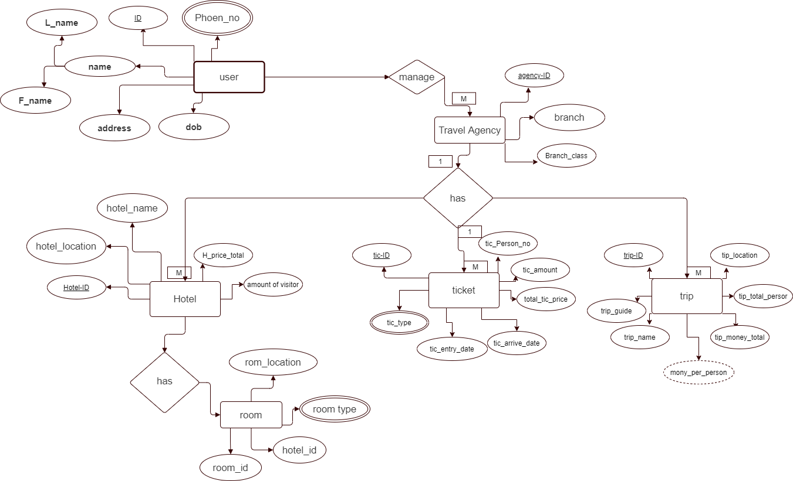

**CHAPTER 4**

**SYSTEM IMPLEMENTATION**

**4.1MODULE DESCRIPTION**

Modules to be used are:

1.**User system:** This keeps the track of all the new customers and old customers as per their regular needs and generates a timely report of it whose one copy is being sent to the customer and another copy is being kept into the company’s database for future reference.

2.**Travel Agent system:** In this module, all the travel agents information associated with the company is kept and all their activities will be tracked.

3.**Package Information system:** In this module, all the information like hotel’s availability, room availability, buses and trains reservation, places to be viewed with tour agents, food to be served, various important timing and all is kept.

**CHAPTER 5**

**SYSTEM TESTING**

**CHAPTER 6**

**CONCLUSION AND FUTURE SCOPE**

**CHAPTER 7**

**REFERENCES**